Protocols and Reserved and commonly allocated ports

Introduction
Today’s businesses depend heavily on websites to reach out to their customers, making it crucial to keep these websites secure from cyberthreats. For instance, suppose that Sam’s Scoops wishes to expand its services online in the future. How can Sam protect the business’ website and the data it handles?
One of the critical factors in website security is network protocols.
Earlier, you learned about ports and how they allow specific applications on a network to send and receive different types of data. You are also familiar with some of the protocols that make data transmission possible. In this reading, you will explore more network protocols that dictate how data is transmitted, received, and processed.
By the end of this reading, you will be able to define different network protocols, describe how they are used for sending information, and identify potential vulnerabilities to prevent attacks on a network.
Network protocols
When it comes to computer networking, network protocols act as the language that allows devices to communicate with each other. Think of it like two people speaking different languages trying to have a conversation - without a common language, they won't understand each other. Similarly, network protocols provide a common language that enables different devices to talk to each other and share information.
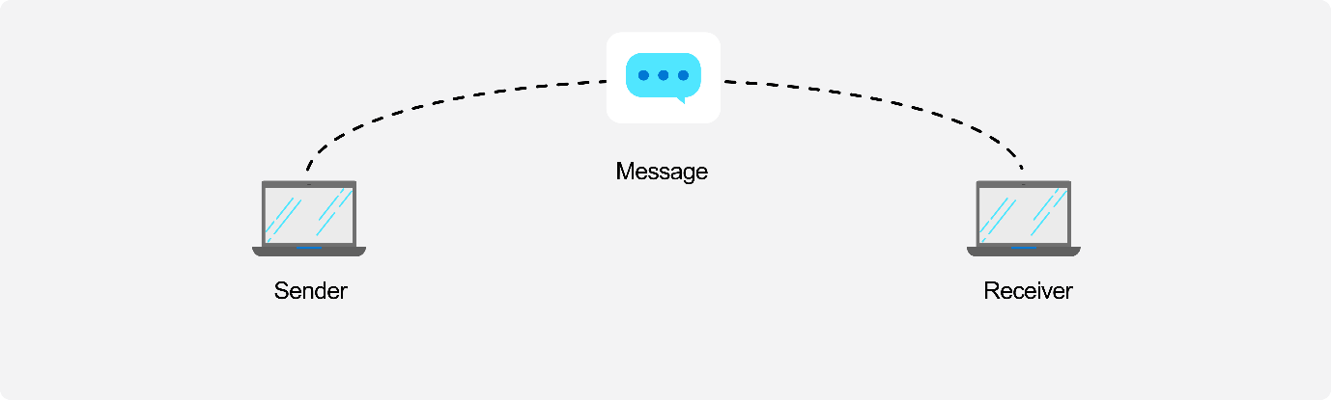
How does this work?
A network protocol is a set of conditions and rules that specify how network devices communicate on a given network. For example, when you use a web browser like Microsoft Edge to visit web pages, it uses protocols to deliver the data to the browser.
Protocols provide a standard framework for establishing and maintaining communication channels and for handling errors or faults should they occur. This allows communication between different network-enabled devices like laptops, tablets, smartphones, desktops, and servers, making network protocols essential building blocks for designing an organization's network architecture.
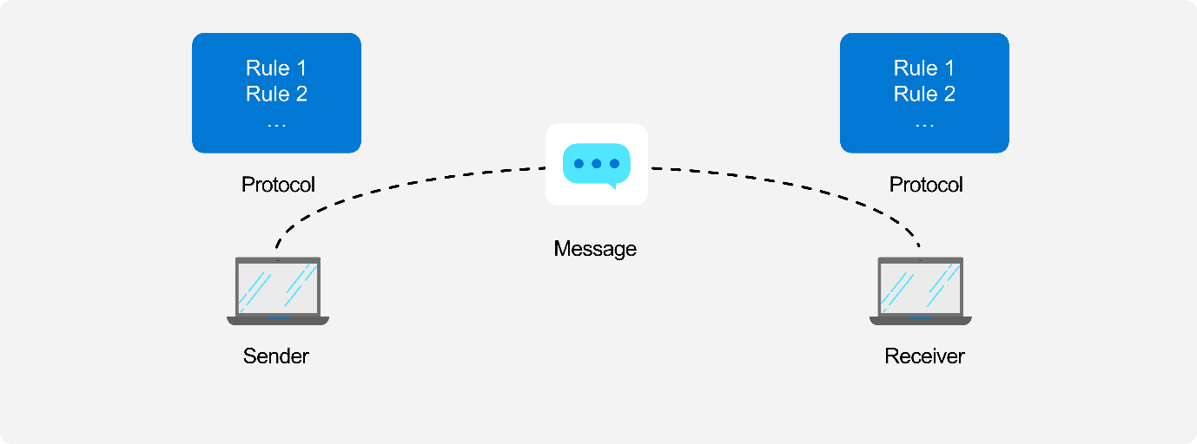
Various types of applications and hardware devices depend on specific network protocols on a typical network. For example, browsing the internet using a web browser requires a different protocol than sending or receiving an email. Each protocol has unique properties that govern its use and implementation.
Network protocols can be grouped into three categories:
- Network communication protocols
- Network security protocols
- Network management protocols
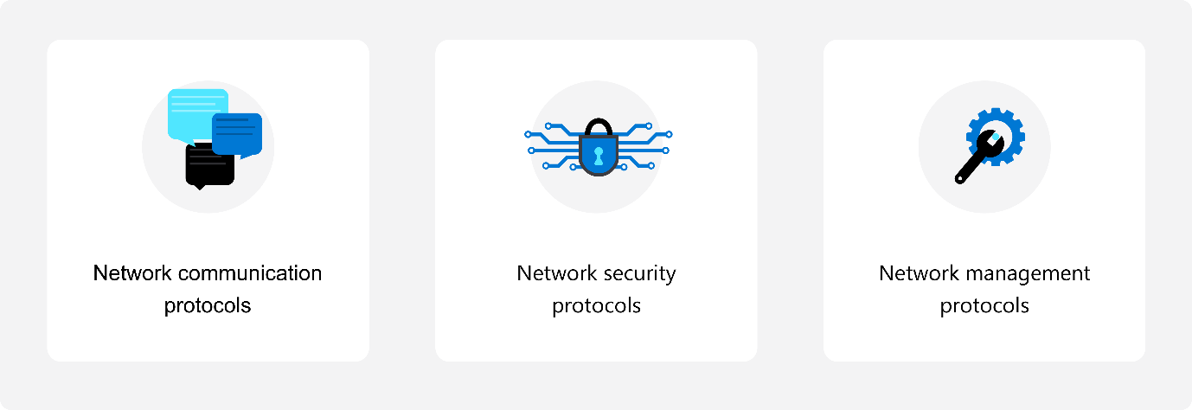
Let’s explore each in a little more detail.
Network communication protocols
Communication protocols focus on establishing and maintaining a connection between devices. As you work with different devices and network services, you'll need to use various communication protocols.
In previous lessons, you learned about TCP and UDP protocols which are used for reliable and unreliable communication.
There are several commonly used network communication protocols, including:
- Hypertext Transfer Protocol (HTTP): The HTTP protocol uses TCP/IP to deliver web page content from a server to your browser. HTTP can also handle the download and upload of files from remote servers.
- File Transfer Protocol (FTP): FTP is used to transfer files between different computers on a network. Typically, FTP is used to upload files to a server from a remote location. While you can use FTP to download files, web-based downloads are typically handled through HTTP.
- Post Office Protocol 3 (POP3): POP3 is one of three email protocols. It's most commonly used by an email client to receive emails and it uses TCP to manage and deliver emails.
- Simple Mail Transfer Protocol (SMTP): SMTP, another email protocol, is used to send emails from an email client via an email server and it uses the TCP for managing and transmitting emails.
- Interactive Mail Access Protocol (IMAP): IMAP is the more powerful of the three email protocols. It lets you manage a single mailbox on an email server in your organization using an email client.
Network security protocols
Network security protocols are designed to maintain the security and network of data across a network. Encryption is a key feature of network security protocols, which involves converting plain text into encoded, unreadable text to protect messages as they travel across the network. These protocols use encryption to secure messages and prevent unauthorized access or tampering.
To implement a secure network, it's important to select the right security protocols based on your specific needs.
The following list explores the leading network security protocols:
- Secure Socket Layer (SSL): SSL is a standard encryption and security protocol. It provides a secure and encrypted connection between your computer and the target server or device that you accessed over the internet.
- Transport Layer Security (TLS): TLS is the successor to SSL and provides a stronger and more robust security encryption protocol. Based on the Internet Engineering Task Force (IETF) standard, it's designed to stop message forgery and tampering and eavesdropping. It's typically used to protect web browser communications, email, VoIP, and instant messaging. While TLS is now used, the replacement security protocol is often still called SSL.
- Hypertext Transfer Protocol Secure (HTTPS): HTTPS provides a more secure version of the standard HTTP protocol by using the TLS or SSL encryption standard. This combination of protocols ensures that all data transmitted between the server and the web browser is encrypted and secure from eavesdropping or data packet sniffing. The same principle is applied to the POP, SMTP, and IMAP protocols listed previously to create secure versions known as POPS, SMTPS, and IMAPS.
- Secure Shell (SSH): SSH is a cryptographic network security protocol that provides a secure data connection across a network. SSH is designed to support command-line execution of instructions, which includes remote authentication to servers. FTP uses many of the SSH functions to provide a secure file transfer mechanism.
Network management protocols
Network management protocols play a critical role in ensuring the smooth operation and sustainability of a network. Alongside communication and security protocols, they enable network administrators to monitor and manage devices and detect faults or performance issues.
To achieve effective network management, administrators must continually monitor all devices on the network. These devices provide indicators about their state and health, which can be accessed using specialized network administrator tools.
Two popular network management protocols are Simple Network Management Protocol (SNMP) and Internet Control Message Protocol (ICMP).
- Simple Network Management Protocol (SNMP): SNMP is an internet protocol that allows for the collection of data from devices on your network and the management of those devices. The device has to support SNMP to gather information. Devices that typically support SNMP include switches, routers, servers, laptops, desktops, and printers.
- Internet Control Message Protocol (ICMP): ICMP is one of the protocols included within the Internet Protocol (IP) suite. It allows network-connected devices to send warning and error messages, along with operation information about the success or failure of a connection request, or if a service is unavailable. Unlike other network transport protocols like UDP and TCP, ICMP isn't used to send or receive data from devices on the network.
The following image illustrates how different protocols function within both the TCP/IP suite and the OSI model. Most of the protocols can be found at the application layer, as these are the protocols that applications use to communicate and pass data. As you move down, other protocols are used to carry this data to the final destination, like IPv4.
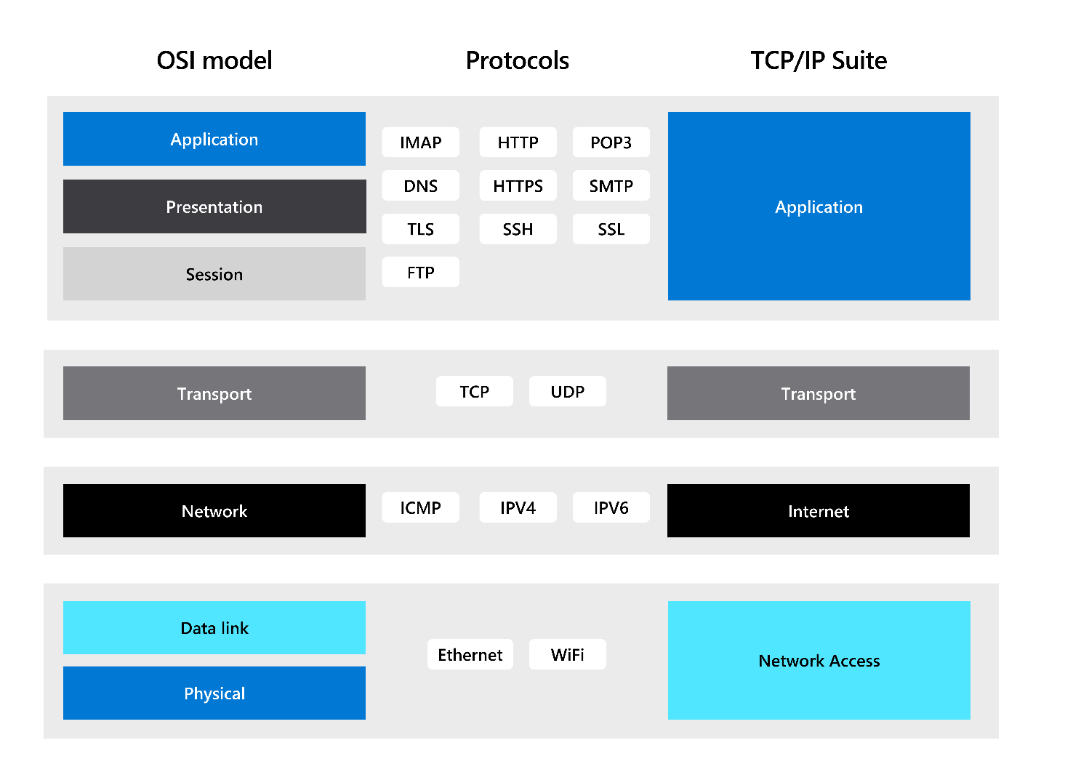
Vulnerabilities
Network communication protocols are necessary to connect devices, but they also present risks. The main problem is that data transfers can be intercepted, and this vulnerability applies to all network communication protocols.

With traffic crossing the internet, there are even more opportunities for attackers to intercept data, and this is known as a man-in the-middle attack. It's like someone listening to your phone conversation while you're in a public place and writing down what you say. Therefore, it's important to be aware of these risks and take steps to secure your network.
When it comes to securing your data, it's always a good idea to choose protocols that offer some level of protection. For example, let's consider HTTP, the protocol used for delivering data between your device and a web page. Unfortunately, it sends all of this data across the network in clear text, making it visible to anyone who may be listening. To better protect your data, you could use HTTPS instead. Like HTTP, it delivers data from a web page to you, but it encrypts the data to keep it secure and disguise it from potential eavesdroppers.
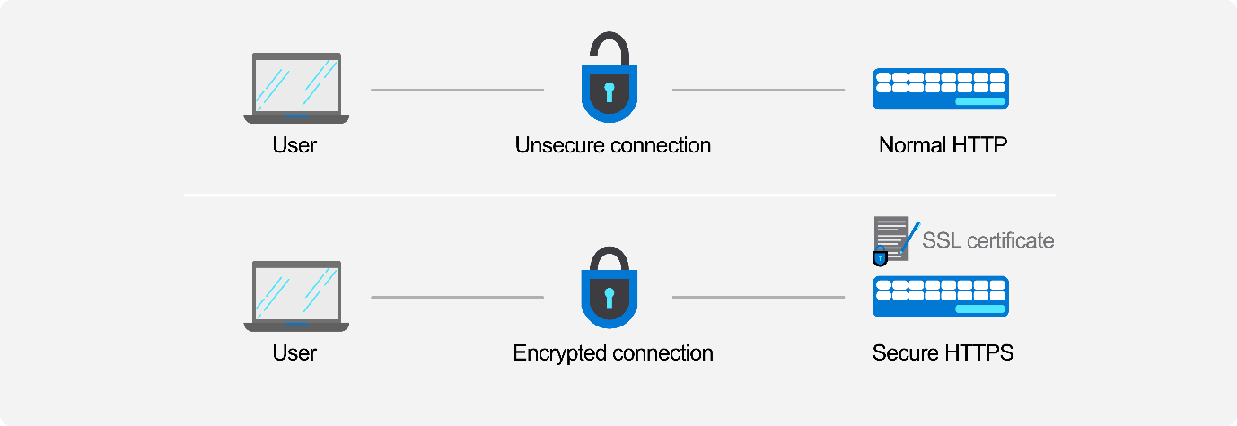
As network security threats continue to evolve, protocols must also adapt to ensure the safety and security of data transfers. Just like HTTP has been upgraded to HTTPS, many protocols have been changed or updated to deal with different vulnerabilities.
Conclusion
Network protocols play a vital role in establishing secure and reliable communication channels between devices on a network. With many different protocols available for different purposes, it's crucial to carefully choose the protocols that will best protect your data from potential vulnerabilities.
In this reading, you’ve learned that, without the right protocols, companies like Sam's Scoops would be at high risk of malicious attacks from hackers and other threat vectors.
Therefore, it's essential for businesses to implement proper network protocols, to safeguard themselves from cyber threats and keep their sensitive data protected.

Reserved and commonly allocated ports
Introduction
As you've learned, port numbers are essential in identifying protocols and services that enable communication between devices. You've also gained familiarity with IP addresses and their division into three classes.
This reading will delve deeper into the classification of port numbers based on number ranges, which is similar to the classification of IP addresses. Understanding these port number ranges is crucial for distinguishing between different sessions across a network between devices. By exploring the various protocols associated with each port number, this reading will be a valuable reference for future use.
Port number ranges
You now know that the range of port numbers used globally is from 0 to 65,535, which is a vast number range. The Internet Assigned Numbers Authority (IANA) manages these port numbers since they change over time as technology and protocols evolve. Any changes made to these port numbers require IANA's permission.
The port numbers are further divided into three ranges, each serving a slightly different purpose in the network. The classification is important in identifying different sessions across a network between devices.
The three port number ranges are:
- Well-known ports (0 - 1,023) are reserved for specific protocols and services used by system processes and applications.
- Registered ports (1,024 - 49,151) are assigned by IANA for specific services or protocols and can also be used by user applications.
- Dynamic or private ports (49,152 - 65,535) are used by client applications to connect to servers and are assigned temporarily for the duration of a session.
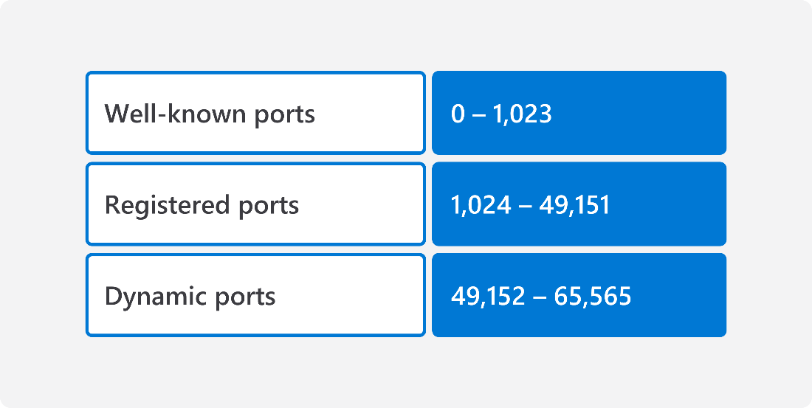
Now that you’re more familiar with the different range classifications, let’s explore each in a little more detail.
Well-known port numbers (0 - 1,023)
Well-known port numbers are reserved for some of the most commonly used and popular protocols in computer networks. These ports can either transfer verified data via TCP or unverified data via UDP. They are assigned at the transport layer of the OSI model or TCP/IP suite and identified at the application layer.
Review the table below for some of the most common well-known ports:
Port Number | TCP\UDP | Protocol | Usage
20,21 | TCP | File Transfer Protocol (FTP) | Data transfer
22 | TCP\UDP | Secure Shell (SSH) | Secure remote device access
23 | TCP | Telnet | Remote device access
25 | TCP | Simple Mail Transfer Protocol (SMTP) | Email
53 | TCP\UDP | Domain Name Server (DNS) | Name to IP address resolution
67,68 | UDP | Dynamic Host Configuration Protocol (DHCP) | Dynamic IP address assignment
69 | UDP | Trivial File Transfer Protocol (TFTP) | Booting devices via the network
80 | TCP | HyperText Transfer Protocol (HTTP) | Web page data transfer
110 | TCP | Post Office Protocol (POP3) | One way mail delivery
123 | UDP | Network Time Protocol (NTP) | Keeps time for the network
143 | TCP\UDP | Internet Message Access Protocol (IMAP4) | Managing mailboxes
161, 162 | TCP\UDP | Simple Network Management Protocol (SNMP) | Network device management
389 | TCP and UDP | Lightweight Directory Access Protocol (LDAP) | Authentication services
443 | TCP\UDP | HTTP with Secure Sockets Layer (SSL) (HTTPS) | Secure web page retrieval
500 | UDP | Internet Security Association and Key Management Protocol (ISAKMP) / Internet Key Exchange (IKE) | Authentication
636 | TCP\UDP | Lightweight Directory Access Protocol over TLS/SSL (LDAPS | Secure authentication services
989/990 | TCP | FTP over TLS/SSL | Secure data transfer
For a complete list of all protocols, please review the following resource from IANA:
- Service names and port numbers
When using protocol port numbers, the destination port is usually specified as the initial step in requesting the correct service from the device that provides the service. If a server can support multiple protocols, the destination port must specify which protocol it wants to use.
The following diagram illustrates how ports are used to identify services:
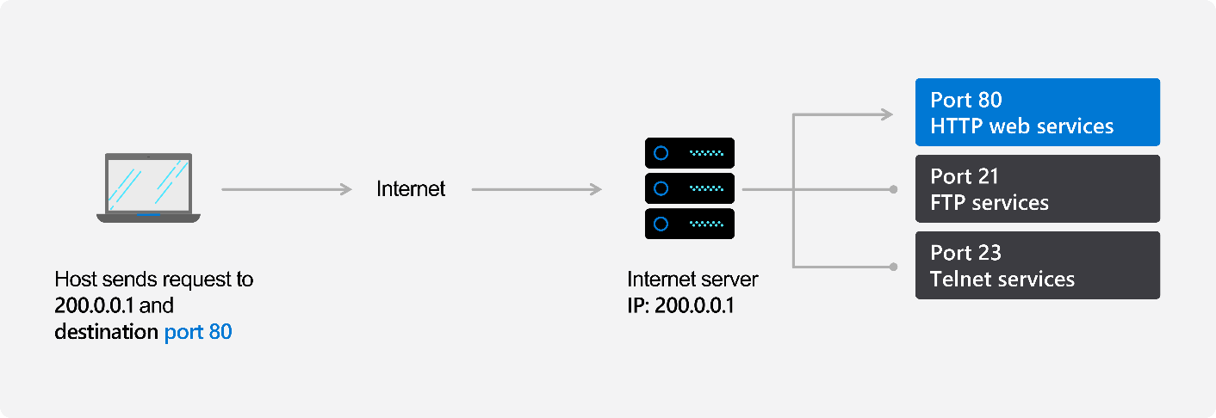
To improve the security of data being transmitted over networks, many protocols now have alternative versions. These alternative versions often involve encryption using a security protocol to enhance security. One such example is HTTPS, which uses the Transport Layer Security (TLS) protocol to encrypt data as it moves across the network. TLS is also used in other protocols to improve their security, with the letter 'S' added to the end of the original protocol name to signify the use of TLS.
Registered ports (1,024 - 49,151)
Registered ports are assigned by IANA to companies for specific services that they want to use. These ports are often used in the gaming sector to identify the ports that need to be opened in home networks to allow games to function.
Examples include port 3074 for the XBOX live network or ports 3,479/80 for the PlayStation network. These ports have changed as games become less relevant and new ones emerge on the market. As technology changes, new ports are assigned and old ones are retired. Some registered ports have been around for a while, such as SIP and H323 which are video conferencing protocols that use port numbers 1,719, 1,720, 5,060, and 5,061. For SIP, port 5,060 is used for unencrypted data, while port 5,061 is used for encrypted data.
Dynamic or private ports (49,152 - 65,535)
Dynamic or private ports are essential for communication between protocols using TCP or UDP. When a computer has multiple web pages open simultaneously, dynamic ports are used to identify different sessions. Each open web page will be associated with a different port number, which serves as the source port number for communication between devices. This is crucial because it allows your computer to determine which data belongs to which web page, and it is also the number used for devices to communicate responses.
The following example demonstrates how a client PC and web server use IP addresses to communicate with each other. In this scenario, the client PC sends a web service request (HTTP request) to the web server using port number 80. The client PC also specifies a source port number (port 5000) for the web server to send its response. This source port number helps the client PC identify which application and session the data is for.
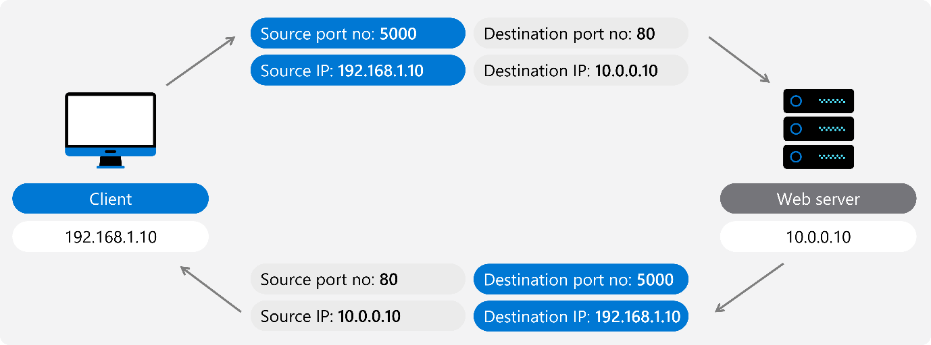
Conclusion
In summary, devices use different port numbers to manage network traffic. Well-known ports are for common applications, registered ports for constantly changing protocols and newer technologies, and dynamic ports for identifying individual sessions. Engineers manage network traffic by configuring and monitoring data flow through specific port numbers, assigning them to specific applications or services, setting up firewall rules, and analyzing network traffic to improve performance.
By managing network traffic effectively, engineers ensure data is transmitted securely and efficiently, and applications and services are accessible to users.

